Create a JS HTML form for Sum of 2 numbers
Using normal textboxes and readonly result textbox
If no values in textboxes and pressed tab (onblur), background should be red and result error


If non numeric values background should be yellow
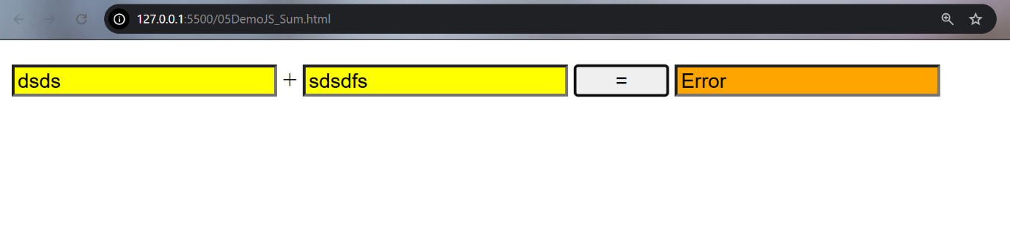

If valid numbers entered, , background should be white and result displayed
